**dutree – A CLI Tool to Analyze Disk Usage in Coloured Output**

**dutree** is a free open-source, fast command-line tool for [analyzing disk usage](https://www.tecmint.com/check-linux-disk-usage-of-files-and-directories/), written in [Rust programming language](https://www.tecmint.com/install-rust-programming-language-in-linux/). It is developed from **durep** (**disk usage reporter**) and **tree** (list directory content in tree-like format) command line tools. **dutree** therefore reports disk usage in a tree-like format.

**Read Also**: [Agedu – A Useful Tool for Tracking Down Wasted Disk Space in Linux](https://www.tecmint.com/agedu-track-disk-space-usage-in-linux/)

It displays coloured output, depending on values configured in the **GNU LS_COLORS** environment variable. This **env variable** enables for setting the colours of files based on extension, permissions as well as file type.

**dutree Features:**

* Show the file system tree.
* Supports aggregating of small files.
* Allows for comparing different directories.
* Supports excluding of files or directories.

**How to Install dutree in Linux Systems**

To install **dutree** in Linux distributions, you must have rust programming language installed on your system as shown.

$ sudo curl https://sh.rustup.rs -sSf | sh

Once **rust** installed, you can run the following command to install strong>dutree in Linux distributions as shown.

$ cargo install --git https://github.com/nachoparker/dutree.git

After installing **dutree**, it uses environment colors according to the variable **LS_COLORS**, it has the same colors ls --color command that our distro has configured.

$ ls --color

The simplest way of running **dutree** is without arguments, this way it shows a filesystem tree.

$ dutree

[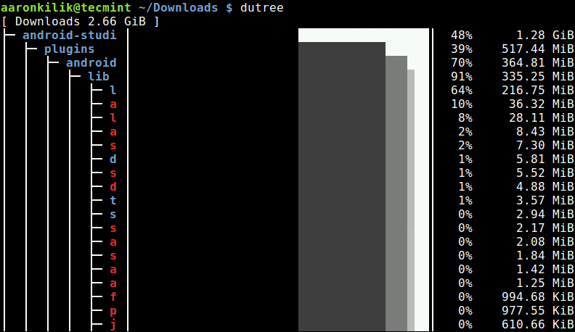](https://www.tecmint.com/wp-content/uploads/2018/04/Linux-Filesystem-Disk-Usage.png)Linux Filesystem Disk Usage

To display real disk usage instead of file size, use the -u flag.

$ dutree -u

[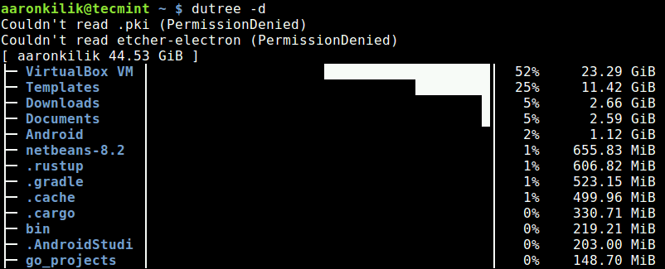](https://www.tecmint.com/wp-content/uploads/2018/04/Show-Linux-Disk-Usage.png)Show Linux Disk Usage

**Show Directories in Depth**

You can show directories up to a given **depth** (default **1**), using the -d flag. The command below will show directories up to a **depth** of **3**, under the current working directory.

For example if the current working directory (~/), then display size of ~/*/*/* as shown in the following sample screenshot.

$ dutree -d 3

[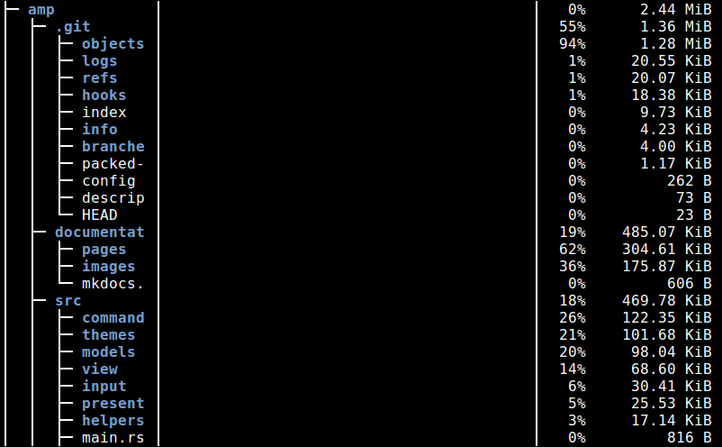](https://www.tecmint.com/wp-content/uploads/2018/04/Show-Directories-in-Depth-Disk-Usage.png)Show Directories in Depth Disk Usage

**Exclude Files or Directories in Output**

To exclude matching a file or directory name, use the -x flag.

$ dutree -x CentOS-7.0-1406-x86_64-DVD.iso

[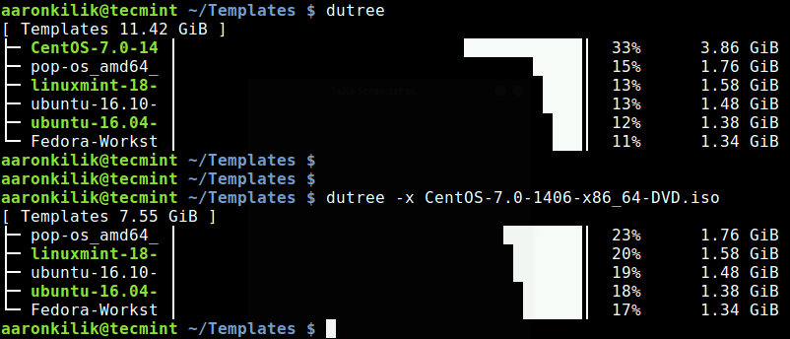](https://www.tecmint.com/wp-content/uploads/2018/04/Exclude-Filename-in-output.png)Show Disk Usage with Exclude Filename

You can also get a quick local overview by skipping directories, using the -f option, like so.

$ dutree -f

[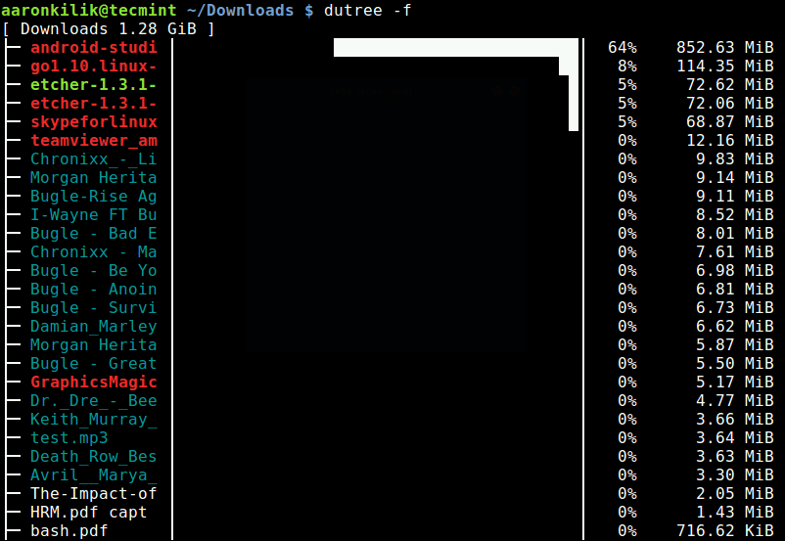](https://www.tecmint.com/wp-content/uploads/2018/04/Quick-Overview-by-Skipping-Directories.png)Quick Overview by Skipping Directories

A full summary/overview can be generated using the -s flag as shown.

$ dutree -s

[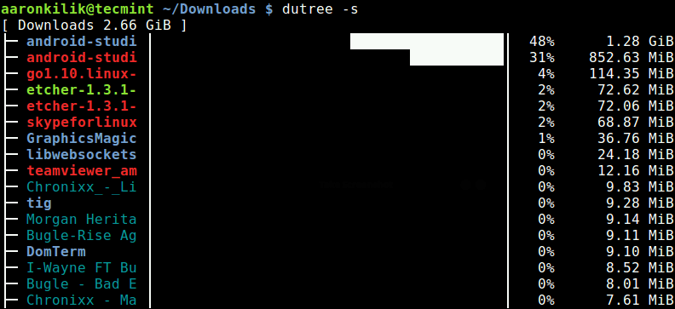](https://www.tecmint.com/wp-content/uploads/2018/04/Linux-Disk-Usage-Summary.png)Linux Disk Usage Summary

**Aggregate Small Files**

It is possible to aggregate files smaller than a certain size, default is **1M** as shown.

$ dutree -a

[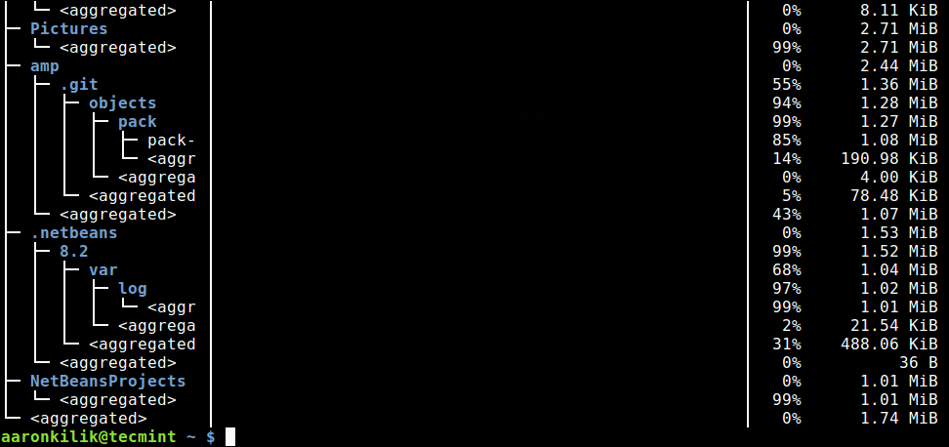](https://www.tecmint.com/wp-content/uploads/2018/04/Aggregate-Small-Files.png)Aggregate Small Files

**Exclude Hidden Files**

The -H switch allows for excluding hidden files in the output.

$ dutree -H

The -b option is used to print sizes in bytes, instead of kilobytes (default).

$ dutree -b

To turn off colors, and only display **ASCII** characters, use the -A flag like so.

$ dutree -A

You can view the dutree help message using the -h option.

**$ dutree -h**

Usage: dutree [options] [..]

Options:

-d, --depth [DEPTH] show directories up to depth N (def 1)

-a, --aggr [N[KMG]] aggregate smaller than N B/KiB/MiB/GiB (def 1M)

-s, --summary equivalent to -da, or -d1 -a1M

-u, --usage report real disk usage instead of file size

-b, --bytes print sizes in bytes

-x, --exclude NAME exclude matching files or directories

-H, --no-hidden exclude hidden files

-A, --ascii ASCII characters only, no colors

-h, --help show help

-v, --version print version number

**dutree Github Repository**: <https://github.com/nachoparker/dutree>

**dutree** is a simple yet powerful command-line tool to show file size and analyze disk usage in tree-like format, on Linux systems. Use the comment form below to share your thoughts or queries about it, with us.